HELP MANUAL

NOTICE BOARD

Campus Together

DHIRUBHAI AMBANI INSTITUTE OF INFORMATION AND
COMMUNICATION TECHNOLOGY (DA-IICT)

GETTING STARTED

1.1 Web Notice Board Manual

1.1.1 View and Manage Notice Board
Supported User Classes: Student, Faculty, Clubs/Committees

Step 1: Click on ‘Notice Boards’ tab on the navigation bar.

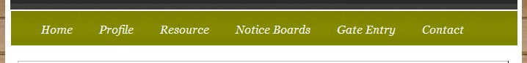

A list of all available Notice Boards would appear.
Each Notice Board will contain its respective Notices
(See Below)
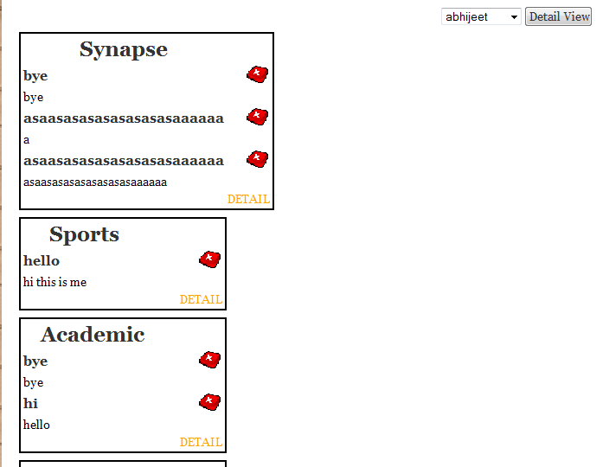
Step 2: Click on ‘RED CROSS’ icon appearing beside each Notice to Delete the Notice.

(Manage Notices)

Step 3: Select a Notice Board from the Drop down Menu and Click on ‘DETAIL’ to view all the notices of that particular Notice Board in detail.

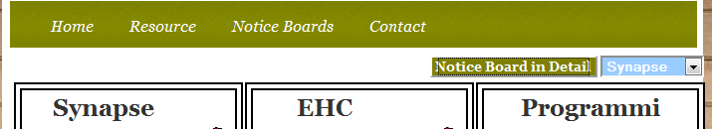

The Detailed View of Notice Board would Open Up.

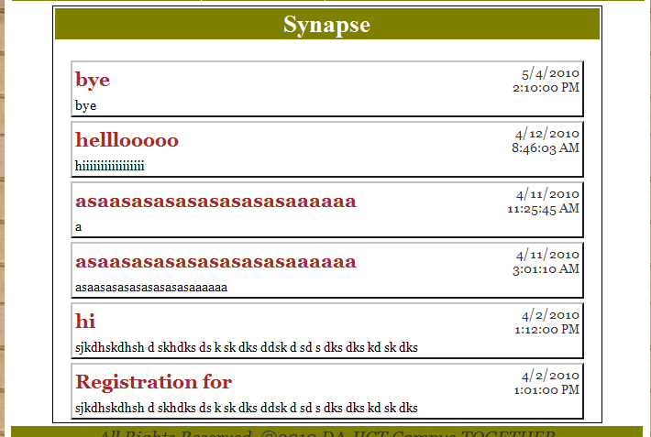

1.1.2 Post a Notice on the Notice Board
Supported User Classes: Clubs/Committees

Step 1: Click on ‘Notice Boards’ tab on the navigation bar.

The following Notice Boards would be available on the webpage.

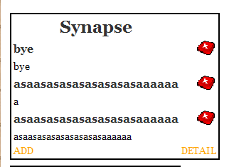

Step 2: Click on ‘ADD’ Button to add a New Notice.

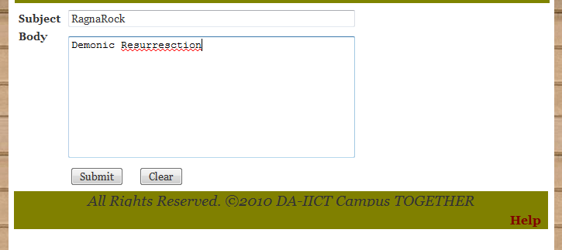

Step 3: Fill the Details as required and Click on ‘Submit’ Button.
The changes would be reflected in the Notice Board.
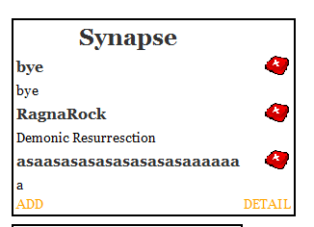

1.1.3 Remove a Notice on the Notice Board
Supported User Classes: Students, Faculty, Clubs/Committees

Step 1: Click on ‘Notice Boards’ tab on the navigation bar.

The following Notice Boards would be available on the webpage.

Step 2: Click on ‘RED CROSS’ Icon to remove a New Notice.

1.1.4 Add a NEW Notice Board on the list.
Supported User Classes: Admin

Step 1: Click on ‘Notice Boards’ tab on the navigation bar.

The following information would be available on the webpage.

Step 2: Click on ‘New Board’ to create a New Notice Board.

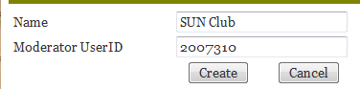

Step 3: Fill the details and Click on ‘Create’ to create a New Notice Board

1.1.5 DELETE a Notice Board on the list.
Supported User Classes: Admin

Step 1: Click on ‘Notice Boards’ tab on the navigation bar.

The following information would be available on the webpage.

Step 2: Click on ‘Delete Board’ to delete a New Notice Board.
--- 0 ---

